**Project Design Phase-II**

**Data Flow Diagram&User Stories**

|  |  |
| --- | --- |
| Date | 23 May 2025 |
| Team ID | LTVIP2025TMID55229 |
| Project Name | LearnHub |
| Maximum Marks | 4 Marks |

**Data Flow Diagrams:**

A Data Flow Diagram (DFD) is a traditional visual representation of the information flows within a system. A neat and clear DFD can depict the right amount of the system requirement graphically. It shows how data enters and leaves the system, what changes the information, and where data is stored.

Example: DFD Level 0 (Industry Standard)

**Example:**

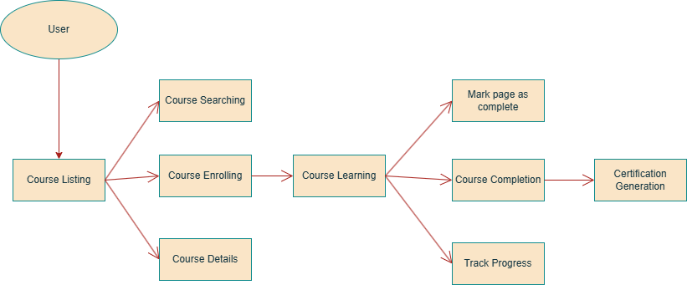

**User Stories**

Use the below template to list all the user stories for the product.

**LearnHub: Product Backlog, Sprint Schedule, and Estimation**

**Updated User Stories by User Type**

| **User Type** | **Functional Requirement (Epic)** | **User Story Number** | **User Story / Task** | **Acceptance Criteria** | **Priority** | **Release** |
| --- | --- | --- | --- | --- | --- | --- |
| Educator | Registration&Account Setup | USN-1 | As an educator, I can register for the application by entering my email, password, and confirming password. | I can create an account easily | High | Sprint-1 |
|  | Course Creation&Management | USN-2 | As an educator, I can create courses. | I can create high quality courses | High | Sprint-1 |
|  | Content Upload&Structuring | USN-3 | As an educator, I can upload videos into my course. Add chapters and pages to courses. | I can add chapters in course, and pages in chapters | High | Sprint-2 |
| Learner | Course Discovery | USN-1 | As a learner, I can find latest technology courses. | I can easily find latest courses | High | Sprint-1 |
|  | Flexible Learning | USN-2 | As a learner, I should be able to learn from the comfort of my home. | I can easily learn any course sitting in my home | High | Sprint-1 |
|  | Multi-language Accessibility | USN-3 | As a learner, I should be able to learn courses in any regional language. | I can learn a course in any language I want | Low | Sprint-2 |
| Learner | Course Certification | USN-4 | As a learner, I can download a certificate after completing a course. | I can generate and download certificates | High | Sprint-3 |
| Learner | Feedback&Ratings | USN-5 | As a learner, I can give feedback and rate the course after completion. | I can submit course reviews and ratings | Medium | Sprint-3 |
| Admin | User Monitoring&Management | USN-6 | As an admin, I can manage users and track all enrolled students. | I can view and manage all platform users | High | Sprint-4 |
| Admin | Course Oversight&Moderation | USN-7 | As an admin, I can manage course listings and remove inappropriate content. | I can approve or remove courses | High | Sprint-4 |